1)

SELECT nuwagon

FROM wagon

WHERE typewagon='frigo' AND capacite>10 AND nomgare='tours';

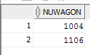

2)

SELECT DISTINCT typewagon

FROM wagon w JOIN train t

ON w.nuwagon=t.nuwagon

WHERE nutrain=4002;

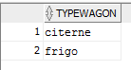

3)

SELECT nuligne

FROM ligne l

WHERE nomgare='tours' AND rang!=1 AND rang!=(

SELECT MAX(rang)

FROM ligne

WHERE nuligne=l.nuligne);



4)

SELECT nutrain

FROM trafic t JOIN reseau r

ON t.nuligne=r.nuligne

WHERE nomgareorigine='angers' AND nomgaredest='beziers' AND nujour='12/03/13';

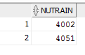

5)

SELECT nuwagon

FROM trafic t JOIN reseau r ON t.nuligne=r.nuligne JOIN train tr ON tr.nutrain=t.nutrain

WHERE nomgareorigine='angers' AND nomgaredest='beziers' AND nujour='12/03/13';

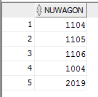

6)

SELECT nuligne

FROM trafic

GROUP BY nuligne

HAVING COUNT(nuligne)=(

SELECT COUNT(DISTINCT nujour)

FROM trafic);



7)

SELECT nomgare

FROM ligne

WHERE nuligne=10 AND rang=(

SELECT MAX(rang)

FROM ligne

WHERE nuligne=10);



8)

SELECT SUM(capacite)

FROM (

SELECT capacite

FROM wagon w JOIN train t

ON w.nuwagon=t.nuwagon

WHERE etat='charge' AND nutrain=4002);



9)

SELECT DISTINCT nomgarearrivee

FROM reseau

CONNECT BY PRIOR nomgarearrivee=nomgareorigine

START WITH nomgareorigine='angers';

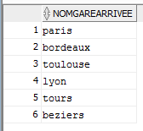

10)

SELECT DISTINCT nutrain, COUNT(nuwagon)

FROM train

GROUP BY nutrain;

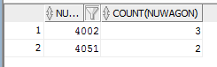

11)

SELECT DISTINCT nutrain

FROM train

GROUP BY nutrain

HAVING COUNT(nuwagon)>=2;

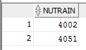

12)

SELECT t.nutrain, t.nuwagon, typewagon, capacite

FROM wagon w JOIN train t

ON w.nuwagon=t.nuwagon;

